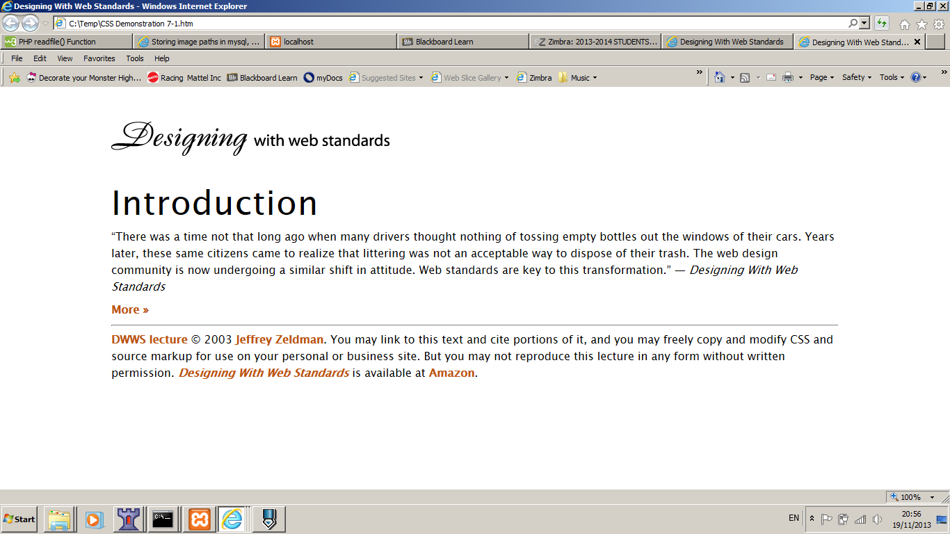

body {

font-family: "Lucida Grande", "Lucida Sans Unicode", Verdana, Lucida, sans-serif;

line-height: 1.5; //increases the height of the lines so you get more space between lines   
 without the need for <br> etc which might be just too much

}

h1 {

letter-spacing:1px;

}

a:link, a:visited {

text-decoration : none;

color: #be540b;

a:hover {

text-decoration : underline;

color: #f79b60; }

bottom paragraph{

color: #999;

}